Blinking Printer Lights
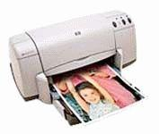

You are experiencing the problem of blinking lights with your HP DeskJet 920C printer: The Power light blinks but the Cartridge & Resume lights are off. This happens when the printer is NOT currently processing a print job.
Go to www.hp.com, and consult their knowledgebase to find out how to solve this problem. Use a time-piece to track precisely how long it takes from the moment the hp home page loads until the solution is found.
- How long did it take?
- Document your navigation (“click”) path.
- Copy and paste your finding: the instructions for fixing the problem

